Rights. Respect. Responsibility. ®: Youth Rights and Sexual Health

Barbara Huberman RN, BSN, MEd

- In the United States, the adolescent birth rate is 9 times higher than that of the Netherlands (four per 1,000 women ages 15 to 19). The U.S. adolescent birth rate (49 per 1,000) is almost five times higher than the rate in France (ten per 1,000) and nearly 4 times higher than that in Germany (12 per 1,000).^{1,}2

- The teen abortion rate in the United States is nearly 8 times higher than the rate in Germany (3.6 per 1,000 women ages 15 to 19). The U.S. teen abortion rate (27.5 per 1,000) is nearly seven times higher than that in the Netherlands (4.2 per 1,000) and nearly three times higher than the rate in France (10.2 per 1,000). ^{3,4}

- In the United States, the estimated HIV prevalence rate in young women 15-24 is 6 times higher than the rate in Germany, nearly 3 times higher than the rate in the Netherlands and is the same as that in France. 5

- In the United States, the estimated HIV prevalence rate in young men 15-24 is over 5 times higher than the rate in Germany, 3 times higher than the rate in the Netherlands and about 1.5 time higher that that in France. 5

- In the United States, the teen gonorrhea rate is over 74 times higher than that in the Netherlands and France. 6

- Finally, in the United States, teens begin having sexual intercourse at the same age or even younger age than teens in the other three nations, but US teens have more sexual partners.7

What happened in the Netherlands, Germany and France that led to such dramatic differences in public health outcomes? How did these countries move to a more open, positive and tolerant view of sexuality? What could we learn from them that might impact on our teen pregnancy and STD prevention programs in the U.S.?

Since 1995, Advocates for Youth and the University of North Carolina at Charlotte have sponsored a national institute each summer to enhance the knowledge and skills of youth risk-behavior professionals in America. In 1998, the Institute became an international 2-week study tour designed to familiarize professionals in the field with programs and policies in Northern Europe. Each year, thirty-five participants are chosen to participate, including masters and doctoral students, prevention advocates, educators, state and national leaders, funders, health care providers, authors, program providers and policy makers.
On January 26, 1999, Advocates for Youth sponsored a symposium on Capitol Hill in Washington, DC and released a monograph on the five issue areas explored by the first Study Tour in 1998, which included:
- the role of media and public education campaigns
- the influence of family, community and religion
- access to health care, especially reproductive health care
- education, particularly sexuality and reproductive health information.
- public policy and advocacy

In 1999, a 15-minute documentary video “Teens and Sex in Europe: A Story of Rights, Respect, Responsibility®,” was produced and is available from Advocates for Youth.

In 2000, 2001 and 2002, state teams of 5-15 key leaders and policy makers from 6 states participated in the Study Tour each year and we encourage additional state teams to apply in the future.

The following are specific “Lessons Learned” from the European Study Tours that illustrate the differences between the US approach to adolescent sexual health and that of the countries studied.

If the US is to embrace a more natural, healthy, and positive philosophy concerning adolescent sexual health, then it is vital that we embrace the “Rights for Youth” which reflect these “Lessons Learned.”

A new paradigm of adolescent sexual health – addressing the whole adolescent person, treating sexuality as natural, normal part of life, and based on three core values will drive a new 10 year national campaign, Rights, Respect, Responsibility® initiated by Advocates for Youth.

- Rights – Adolescents have the right to balanced, accurate, and realistic sexuality education, confidential and affordable sexual health services, and a secure stake in the future.

- Respect – Youth deserve respect. Today, they are perceived only as part of the problem. Valuing young people means they are part of the solution and are included in the development of programs and policies that affect their well-being.

- Responsibility – Society has the responsibility to provide young people with the tools they need to safeguard their sexual health and young people have the responsibility to protect themselves from too early childbearing and sexually transmitted infections, including HIV.

This campaign will engage national and state partners and support changes in policies, practices, and systems that help normalize these values in our country.

Lessons Learned Rights for Youth
Adults in the Netherlands, France, and Germany view young people as assets, not as problems. Adults value and respect adolescents and expect teens to act responsibly. Governments strongly support education and economic self-sufficiency for youth. |  | Young people have value and deserve education and the knowledge and skills necessary for self sufficiency and good health.
The morality of sexual behavior is weighed through an individual ethic that includes the values of responsibility, love, respect, tolerance, and equity. The morality of sexual behavior is not the result of collective force, such as religious dogma. |  | Young people deserve respect and support as they develop values of tolerance, responsibility, and equity. They deserve to be listened to and to have their opinions, beliefs, and feelings accepted.
Families, educators, and health care providers have open, honest, consistent discussions with teens about sexuality. Such discussions do not result in early sexual activity. |  | Young people deserve open, honest discussions about sexuality and intimate relationships from their families and other trusted adults in their communities.
Adults see intimate sexual relationships as normal and natural for older adolescents, a positive component of emotionally healthy maturation. Young people believe it is “stupid and irresponsible” to have sex without protection and use the maxim, “safe sex or no sex.” Marriage is not a criteria for intimate relationships. |  | Young people deserve to grow up in aculture where sexuality is perceived as normal, healthy, and positive.
Marriage is not a criterion for intimate sexual relationships for older adolescents. |  | Young people deserve respect in their  individual choices about intimate  relationships.

Lessons Learned Rights for Youth
The major impetus for improved access to contraception, consistent sexuality education, and widespread public education campaigns is a national desire to reduce the numbers of abortions and to prevent HIV infection. |  | Young people deserve support from society in their efforts to act responsibly within intimate relationships.
Sexually active youth have free, convenient access to contraception through national health insurance. Emergency Contraception is available over the counter. Condoms are available in public places like metro and train stations. |  | Young people deserve convenient and low cost or free health care services. Young people deserve barrier free access to contraception, condoms, and sexual health services.
Sexuality education is not necessarily a curriculum; it may be integrated through many school subjects and at all grade levels. Educators provide accurate and complete information in response to students’ questions. |  | Young people deserve balanced, accurate sexuality education in their schools and open, honest answers to their questions.
Governments support massive, consistent, long-term public education campaigns utilizing television, films, radio, billboards, discos, pharmacies, and health care providers. Media is a partner, not a problem, in these campaigns. Sexually explicit campaigns arouse little concern. |  | Young people deserve healthy, realistic, and responsible media messages that support responsible sexual behavior.
Research is the basis for public policies to reduce pregnancies, abortions, and STDs. Political and religious interest groups have little influence in public health policy. |  | Young people deserve public health policies that are based on research and that promote scientifically evaluated, effective programs rather than policies based on ignorance, fear, or prejudice.

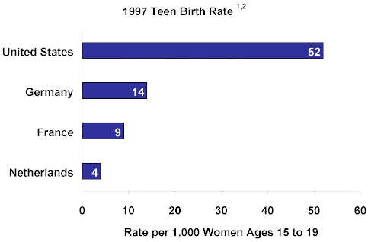
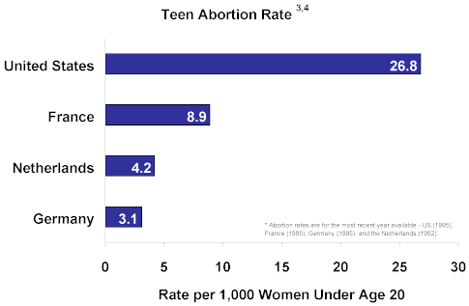

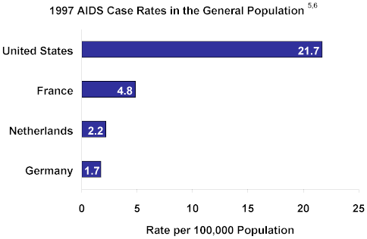

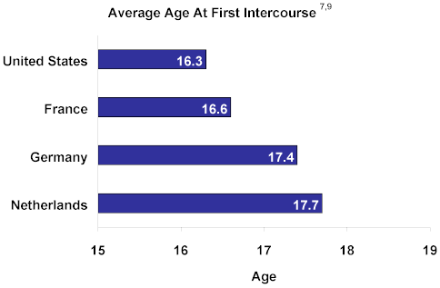
Lower Rates Mean Fewer Births and Abortions among Teens
- and Lower Public Costs

If Society in the United States became more comfortable with sexuality and if public policies were based in pragmatism, sexual health indicators could improve markedly. Comfort with sexuality and more pragmatic, research-based prevention strategies would mean greater, easier access to sexual health information and services for American teens. Imagine that the United States adolescent birth and abortion rates could be reduced to match those rates in any of the three European nations studied.

The reduced adolescent birth and abortion rates would mean large reductions in the annual numbers of births and abortions to teens in the United States and in the public funds needed to support families begun with a birth to a teen. How would this look?

If the U.S. Rates Equaled Rates in: | Fewer births | Fewer abortions | Lower Public Costs⁸
Netherlands | 426,991 | 213,886 | $891 million
France | 373,806 | 155,366 | $780 million
Germany | 349,631 | 219,188 | $730 million

2 Singh S, Darroch JE. Adolescent pregnancy and childbearing: levels and trends in developed countries. Family Planning Perspectives 2000;32(1):14-23
58Calculations based on Feijoo AN. Teenage Pregnancy, the Case for Prevention. Washington DC: Advocates for Youth, 1999. 4Martin JA et al. Births: preliminary data for 2000. National Vital Statistics Reports 2001;49(5):1-20. 3Rademakers J. Sex Education in the Netherlands. Paper presented to the European Study Tour. Leiden, Netherlands:NISSO, 2001. 1Ventura SJ et al. Trends in pregnancy rates for the United States, 1976-97: an update. National Vital Statistics Reports 2001;49(4):1-10. 5 UNAIDS. Report on the Global HIV/AIDS Epidemic. Geneva, Switzerland: UNAIDS, 2000.
5
6 Panchaud C et al. Sexually transmitted diseases among adolescents in developed countries. Family Planning Perspectives 2000;32(1):24-32&45.
7 Darroch JE et al. Adolescent Sexual and Reproductive Health : A Developed Country Comparison. New York, NY: The Alan Guttmacher Institute, forthcoming K:\BH\Articles\3R’s-Youth Rights & Sexual Health.doc

