Obesity – A Problem for the 21st Century

Introduction

The increasing prevalence of obesity in children and youth is becoming a major public health concern for the new millennium.

It is a problem especially in the developed world and also in developing countries. Obesity has been found to be a problem in countries from China to the Caribbean and parts of South America.

I will discuss some of the reasons why this has become a problem and what are the consequences for the health profession and society at large.

Many national organizations in North America have become concerned about these issues. A few years ago, the Canadian Paediatric Society decided to focus on the area and formed an Advisory Committee on Healthy Active Living for Children and Youth with a membership of physicians with varied backgrounds including exercise science, nutrition, family medicine and paediatric practise. I represent the Committee on adolescent health issues.

We went through the background of the problem and effects of obesity including dietary and the ever-decreasing amount of exercise among young people, and produced a position statement on this. We also came up with recommendations for health care professionals and a brochure for parents. These are at the end of the paper.

This is a long topic, so I will just discuss some of the highlights.

Definitions of Obesity

- Usual weight expressed is percentage of ideal weight for height, age and sex.

Actual weight (kg) X 100

Ideal weight

Normal weight index | 90 – 100%
Overweight | 100 – 120%
Obesity | < 120%

- Body Mass Index (BMI)

Weight (kg)_____
Height in metres²

At risk | < 85th percentile
Obesity | < 95th percentile

There are now graphs for ages 2-20 produced by the Center for Disease Control (CDC) in the United States.

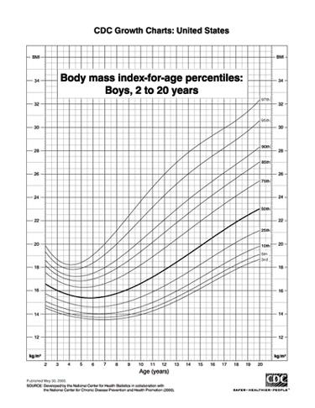

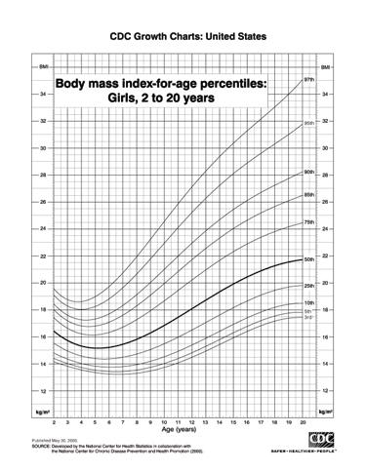

Obesity Statistics

- 25% of North American children are overweight

- Canadian prevalence obesity tripled 1981 – 1996 *

- 40% obese children and 70% obese teens become obese adults

- 1/6 Canadian adults obese

* Tremblay and Willms CMAJ 2000; 163(11): 1429-1433; CMAJ 2001; 164(7): 970

Physical inactivty Statistics

There is a decline in physical activity in girls during adolescence

A longitudinal study of black & white girls measuring recreational activity from the age of 8 or 9 through 18 or 19 years

56% of black girls and 31% of white girls reported no habitual recreational activity

S.Y.S. Kimm et al, NEJM, September 2002

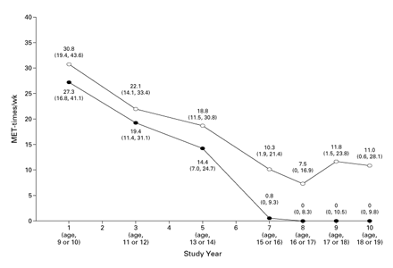

Dietary Factors

Convenience foods, convenience preparation – high calorie & fat content

Fast-foods

Reduced fruit and vegetable intake

Media – advertising food, enhanced food portions and inappropriate body image ideals

Effects on Health

With the increase of obesity, medical complications will rise causing an ever-increasing burden on society.

- Hypertension

- Dyslipidaemia

- Endocrine – Type 2 diabetes mellitus
- 1,2,3, associated with arteriosclerosis premature strokes and coronary artery disease
- Polycystic ovary syndrome & irregular menses

- Gastroenterological problems
- Gall stones
- Steatohepatitis – fatty liver

- Respiratory
- asthma, sleep apnea

- Neurological
- pseudotumour, cerebri

- Osteoporosis

- Orthopaedic
- Slipped capital femoral epiphysis, Blount's disease (tibia vara)

- Mental health
- 1996-97: 113,000 Canadian adolescents from 12-17 years were diagnosed with depression. Juvenile obesity is associated with poor self-esteem and social discrimination. Regular physical activity is associated positively with self-esteem and self-concept regardless of weight. Physical activity is associated with a reduction in smoking, alcohol and drug use.

Causes

Negative aspects of a convenience society (Dr. Glenn Berall)

- Convenience food
  - Reduction in fat intake, fruit and vegetables
  - Fast food, convenience foods (high calories)
  - Advertising

- Convenience transportation
  - Ease of transportation: children walk less and often do not walk to school
  - Perception of unsafe neighbourhoods

- Convenience entertainment
  - TV
  - Computers
  - Video Games
  - Eating by the TV

- Convenience education
  - Reduced physical activity and sports
  - Short time for eating and high-calorie meals

- Genetics
  - Although inheritance plays a part it is not the reason for the recent rapid increase in obesity
  - Mono-genetic conditions – Prader Willi syndrome, Bordet Biedel syndrome

The following information on activity and diet is from the brochure on Healthy Active Living for Children and Youth of the Canadian Paediatric Society.

Prevention

- Requires a re-education of society

- Education regarding diet and increased activity at schools

- Discourage high-calorie foods and soft drinks

- Early identification

- Family involvement

Get Active

- Get the whole family involved in regular physical activity and health eating. It will be easier if everyone's in it together. If you focus on just one child, they may feel like they're being punished.

- If your children are not active, increase the time that they currently spend on physical activities and sports by at least 30 minutes a day. They should spend at least 10 minutes on "vigorous activity", which makes their hearts beat faster, makes them breathe harder, and makes their bodies feel warm.

- Make active living part of your child's daily routine. It's easier and more realistic than relying on scheduled, organized activities.

- Encourage your child to take part in activities that involve moving, not sitting. Set limits on how much time they spend watching TV, playing video games, and surfing the Internet – no more than one hour a day.

- Organized sports alone (such as a soccer team or a hockey league) aren't enough to keep children and youth healthy. Encourage them to also discover activities they can do and enjoy every day, such as walking or cycling to a friend's house or skipping rope.

- If you drive your children to school, try walking instead, or organize a walking club with the neighbours.

- Encourage your children to take the stairs instead of the escalator or elevator.

- Get your child involved in activities around the house: carrying the groceries, raking leaves, or shovelling snow.

- Be sure activities are safe. Children and youth should wear protective equipment for activities like cycling, skating, skateboarding, soccer, and other physical activities.

Eating Well

- Limit the amount of high-fat, high-calorie foods you bring into your home. It's easier for children to make healthy choices if there's no junk food around to tempt them. If you do bring home foods like chips or cookies, buy smaller packages.

- Help your children choose foods that are high in cereal fibre – like bran, wheat and rye. These include dry cereal or cereal bars, which are naturally filling and low in calories.

- Provide your children with healthy snacks. Instead of high-fat foods like chips and donuts, offer fruit and raw vegetables, like celery and carrots.

- Encourage your child to drink water instead of juice. Even juice that is labelled "unsweetened" can have as many calories as soft drinks. Set a limit on juice and soft drinks. Aim for no more than 4 to 8 oz a day, depending on your child's size and weight.

- If your children eat at fast food restaurants, help them resist the temptation to "supersize" their meals. Stick with regular portions, and don't go as often.

- Help your child or teen accept their body. Instead of dieting, encourage them to get active. Dieting leads to a "yo-yo" cycle of weight gain and weight loss that is not healthy.

- If your child is overweight, talk to your doctor about setting realistic weight-loss goals, and about developing a plan to reach those goals.

